Introduction to Mongodb and its query performance comparison with Oracle

By Mohit ([beniwal@bu.edu](mailto:beniwal@bu.edu))Bu id: - U33745431

Abstract

In the Current scenario there are two type of Database Management System, Relational Database and Non-Relational Database. Relational database stores structured data in proper pre-defined schema, such as Oracle, MySQL, Microsoft SQL server. On the other hand, Non-relational database can store unstructured data which can grow in real-time, and there is no need to pre-defined the schema for NoSQL databases. There are different type of NoSQL database and this classification is based on the way these databases store data.

According to

<https://www.mongodb.com/scale/types-of-nosql-database-management-systems>

Mainly there are four types of NoSQL Dbs:-

1. Document Based Store E.g.: - MongoDB
2. Graph Based Store E.g.: - Neo4j and Giraph
3. Key-Value Store E.g.: - Amazon DynamoDB
4. Column Based Store E.g.: - HBase and Cassandra

Relational databases are widely used in industry as they provide query compatibility, transaction management and other rich set of features. However, as they can’t store and process unstructured data. To resolve this issue companies like Google, Facebook, Twitter, Amazon developed these big databases to support their huge userbase websites.

I have chosen Oracle as the RDBMS (Relational Database Management System) and MongoDB ad the NoSQL (No-SQL or Not Only SQL) to perform a query performance comparison. Because for the above mentioned databased are widely used in the industry.

Content

* MongoDB Document database
* MongoDB Setup
* How to query in MongoDB
* How to backup and restore MogoDB
* Query Comparison with Oracle
* Conclusion
* References

Mongo dB

According to <https://docs.mongodb.com> MongoDB is a widely used flexible and scalable Document-oriented database. It stores data in flexible, JSON like documents, Binary JSON(BSON) it Support Ad hoc queries, indexing and real time aggregation including MapReduce. Its DB server and tools written in C++ and are open-sourced. Ans of course it is distributed at its core. It uses BSON which is the binary encoding of the JSON type document because it is efficient than JSON in term of Storage Space and Scan Speed. BSON also support data types like Date and Binary which is not supported in the JSON.

SQL terms v/s MongoDB terms

|  |  |
| --- | --- |
| SQl | MongoDB |
| Database | Database |
| Table | Collection |
| Rows | Documents |
| Columns | Fields |

Sample JSON File

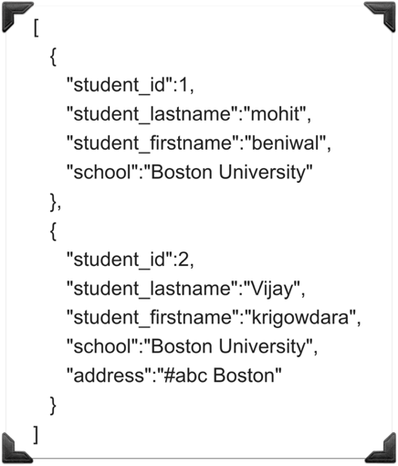

JSON file as you can see in the above screenshot starts with square brackets and can contains comma separated documents inside it as there are two documents in the screenshot. We can pass documents with different fields, like in the second document there is an extra fields “Address”. As in MongoDB schema is not predefined so it will accept the document and process it. Example:-

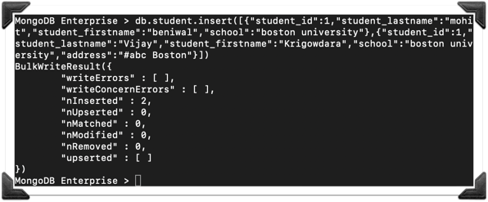

Sample BSON File

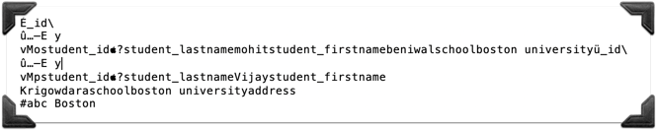

This is the BSON file for the above shown JSON, which is partially unreadable.

MongoDB Setup

We can easily download the mongoDB and its query tools from the fellow links and it support all the platforms shown in the screenshot.

MongoDB: - <https://www.mongodb.com>

Query Tool: - <https://robomongo.org>

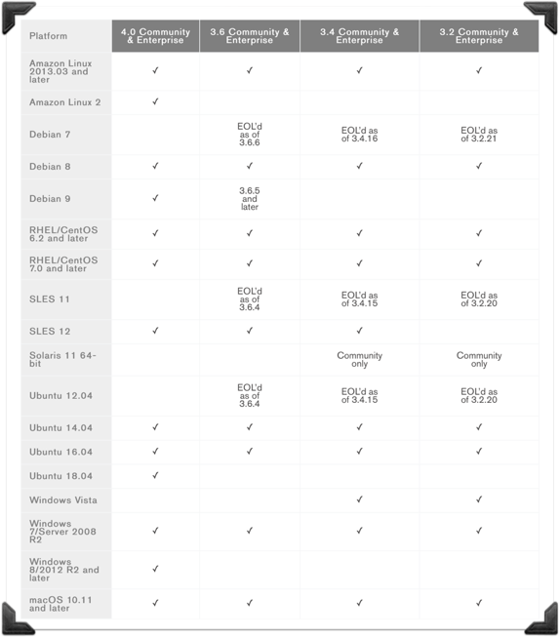

The above screenshot is taken from: - <https://docs.mongodb.com/manual/administration/production-notes/>

Getting Started with MongoDB

Step 1:- To start mongodb on your machine we need to open terminal and run command “mongod” first.

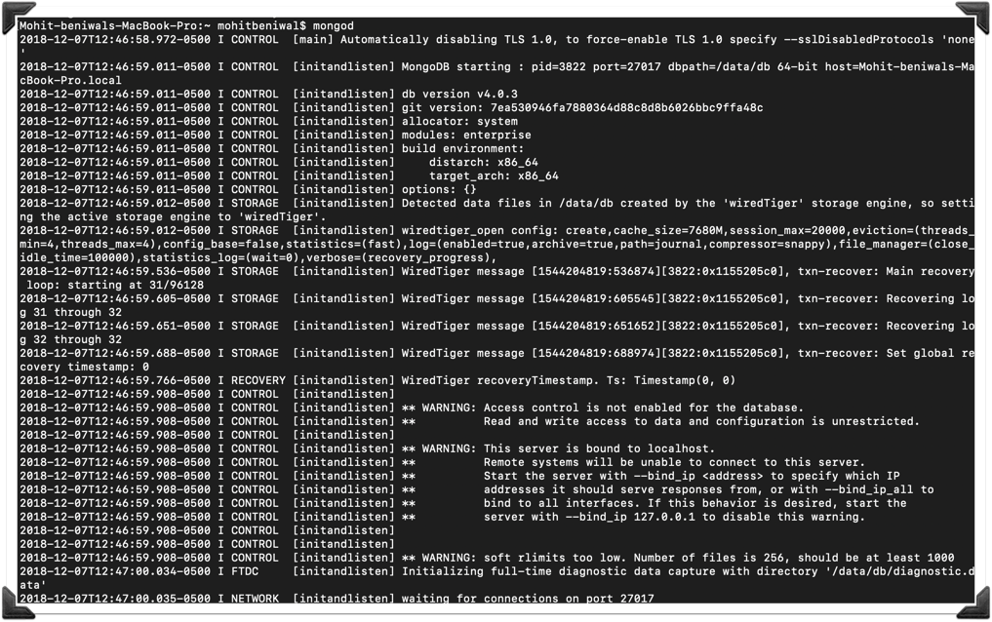

So now we are ready to connect mongo shell on port 27017, look at the last line in the screenshot it says “waiting for connection on port 27017”.

Step 2: - We need to open one more terminal window and run command “mongo”.

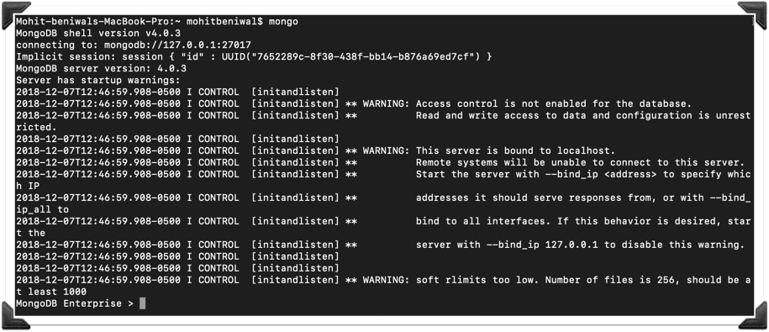

Now mongo shell is up and running.

Querying in MongoDB

1. Create database: - use databaseName



Use command will create a database if the mentioned database doesn’t exist otherwise it will simply switch to the mentioned database.

1. List all databases: - show dbs

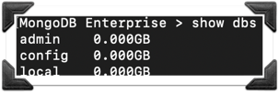

This command will list all the databases present. In the screenshot we can three databases, these DBs comes by default.

* Admin: -

It stores system collections and user authentication and authorization data, which includes the administrator and user's usernames, passwords, and roles.

* Config: -

Config DB is not a dependable API and it may change between mongodb releases.

* Local: -

It stores data used in the replication process. And itself is invisible from replication.

**Note**: -

You must have noticed that the DB we created in the previous step is not listed. That is because we haven’t created any collection for that DB yet.

1. Create Collection: -

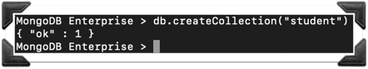

This command will create a collection named “student” in the database which we are using right now.

1. Insert into Collection: -

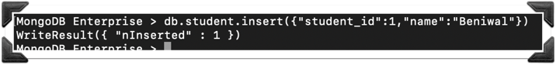

This command will insert one document in the “student” collection with fields “student_id” and “name”. If the used collection is not present in that case mongo will automatically create the collection and insert the data.

1. To list current DB: -

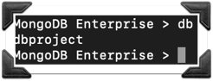

This command will return the DB name which is being used at the moment.

1. Drop DB: -

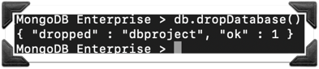

This command will drop the DB being used.

1. List all collection: -



This command will return the collection name of the DB being used.

1. Drop Collection: -

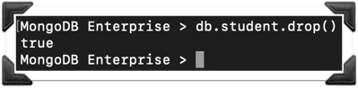

This command will return true on successfully drop of a collection. In this screenshot “student” collection is being dropped.

1. Insert multiple documents: -

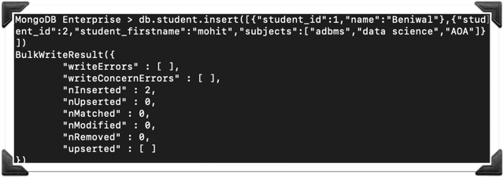

This query will in insert two documents into student collection.

1. Select query: -

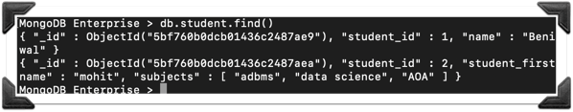

This query will fetch all the records from the student collection. If we look closely into the screenshot we can see there is a field “_id” which we haven’t inserted into the collection. Actually, Mongodb while inserting checks for the _id field if it is not provided by the user it automatically generates a unique _id and insert into the collection.

1. Select Pretty: -

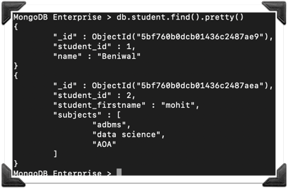

This query is same as the previous one but we are using pretty () to get the result into more readable format.

1. Find One : -

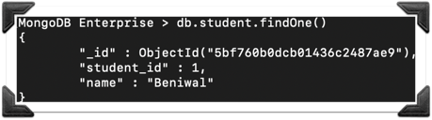

This query will fetch only the first document of the collection.

1. Find with condition: -

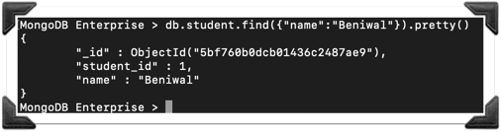

This query will fetch only those documents which contains “name” as “Beniwal” from the student collection.

1. Find using comparison operator : -

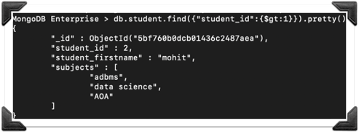

Greater than: -This query will fetch the documents where “student_id” is greater than 1.

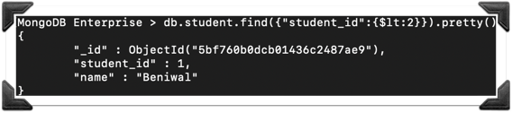

Less than: - This Query will fetch the documents where “student_id” is less than 1.

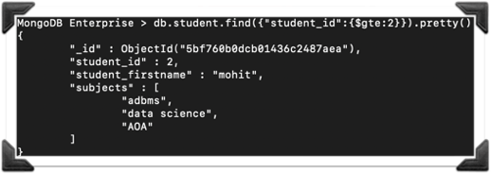

Greater than and equal: -This query will fetch the documents where “student_id” is greater than or equal to 2.

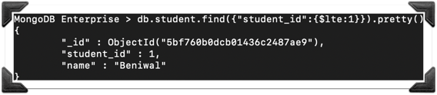

Less than and equal: -This query will fetch the documents where “student_id” is less than or equal to 1.

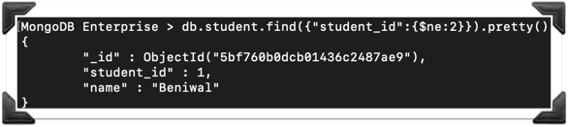

Not equal:- this query will fetch the documents where “student_id” is not equal to 2.

1. Find using and/or operater: -

And: -

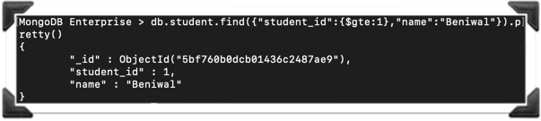

This query will fetch the documents where “student_id” is greater than or equal to 1 and “name” is “beniwal”. So simply we can use comma between two or more condition to feth the documents.

Or: -

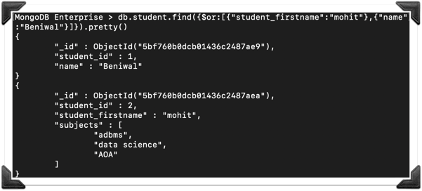

This query will fetch the documents where “student_firstname” is “mohit” or “name” is

“beniwal”. We need to put $ symbol then or nad we need to pass the condition in a

square bracts as shown In the screenshot.

1. Find only the necessary data: -

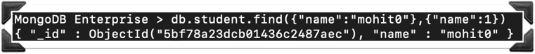

This query will fetch only the “name” field from the documents where condition satisfies. But as we can see in the result we can see field “_id:” is also there.

To remove “_id” from the result we do some modification in the query as follows.



1. Skip First: - At this point of time we have 100 document in the student collection where “id” ranges from 0-99.

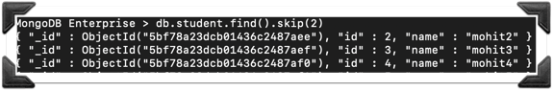

This query will skip first 2 documents and fetch all other records from the student.

1. Limit: -

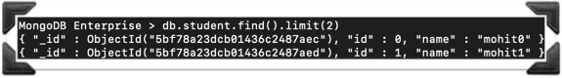

This query will fetch only first 2 documents from the student collection as we are passing 2 to the limit function.

Skip & limit:- we can use both limit and skip as follows

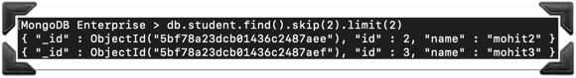

1. Sorting: -

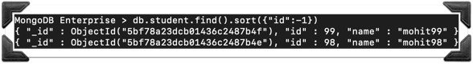

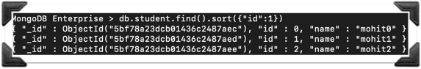

These queries will sort the resulted documents according to the “id”. -1 represent the descending order and 1 represent ascending order.

1. Update Query: -



This query will update only the first document which satisfies the condition. To update multiple documents in a single query we need to add {multi: True} in the query as follows.



1. Save: - By using save() we can update or insert a document. If it will found a document with the same “_id” then it will update that document otherwise it will insert a new document into the collection.

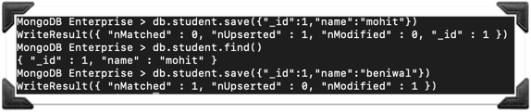

First tried to save with “_id”:1 and “name”:”mohit” as there was no matching records so it inserted 1 document.

Second command will show the inserted document.

Third command we are trying to save with same “_id” and different “name” so it will update the document. You can see in the result “nMatched”: 1 and “nModified” : 1.

1. Deletion: -



This query will delete all document from student collection where “name” is “Mohit beniwal”.

If we want to delete only 1st found document we can modify the query as follow.



Instead of 1 even if we pass any other value (negative or positive). It will only delete the first occurrence.

1. Aggregation: - SUM, MAX and MIN

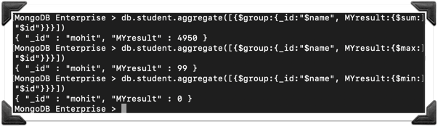

In these 3 queries we are grouping by “name” and applying SUM,MAX and MIN in “id” and aggregated result is being represented as “MYresult”.

1. Indexing: -

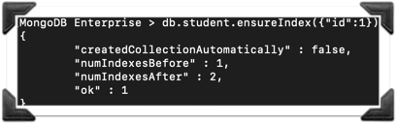

We can use the above command to ensure indexing on collection. In the above screenshot we are ensuring indexing on “id” field.

To remove indexing we can use the following command: -

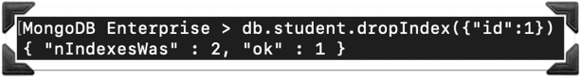

Backup and Restore

**Note:** - Sometime when we run the mongodump or mongorestore it shows that unable to connect to the server in that case we need to append “- -host=127.0.0.1” to our command. If it is able to connect then host part of the command is not necessary.

Step 1: -

To take backup we need our mongo shell up and running.

Step 2: -

We need to open a new terminal window and then we need to set the directory wherever we want to take the backup.

Step 3:-

We need to run command “mongodump”. This will take backup of all of the dbs.

If we want to take backup of only one dbs that we are using then we can do as follow.

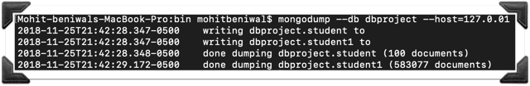

This will take backup of only the mentioned DB which is “dbproject” in this case. It will create a dump folder which we contain a folder named same as your DB name and inside that you will found JSON and BSON files.

Step 4: -

Go to your mongo shell and drop your DB(Just for testing).

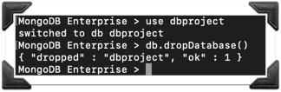

Step 5:-

For restoring DB we need to run mongorestore command along with the DB name that we need to restore and the path of the dump folder.

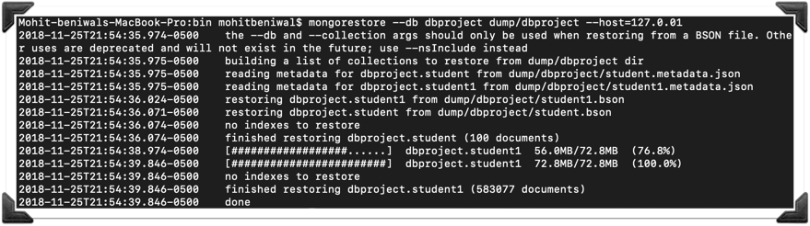

Comparison with Oracle

I have performed this comparison in virtual machine by running same type of insert, select, update and delete query in both MongoDB and Oracle.

**Insertion:-**

MongoDB collection Creation: -

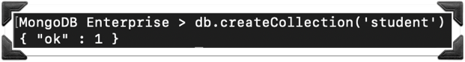

Before inserting data into MongoDB I would like to explain about the **Profiling Level** in MongoDB. There are 3 profiling levels In mongoDB as shown.

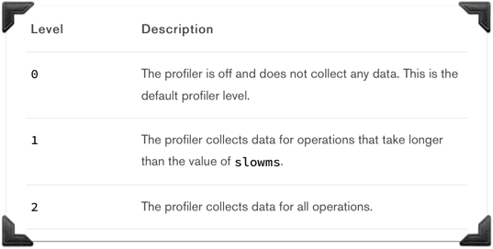

The above Screenshot is taken from :-

<https://docs.mongodb.com/manual/reference/method/db.setProfilingLevel/>

After creating a DB we can check the profiling level as shown: -

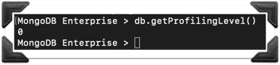

We will be using profiling level 1, and we can set that as shown : -

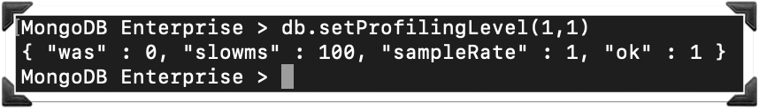

We are passing 2 parameters into setProfilingLevel(), 1st one represent the level and the 2nd one represent the time. For the above command profiler will collect the data of all the queries which take more than 1 ms as we are padding 1 as the 2nd parameter.

MongoDB insertion: -

We will be using command “mongoimport” to import data into a collection from a JSON file.

Command: - mongoimport --jsonArray --db test --collection student --file /users/mohitbeniwal/downloads/student100.json

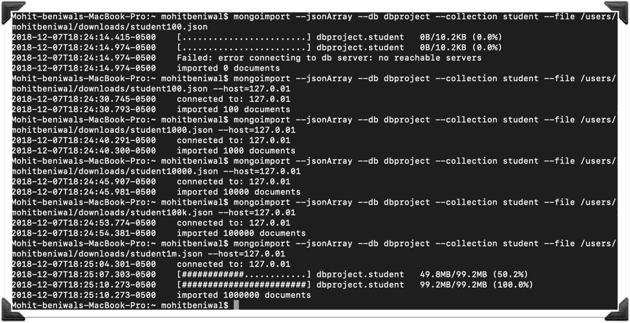

Use - - host=127.0.0.1 if you face no reachable server.

Now if we go to mongo shell and check for the data collected for the insert statements: -

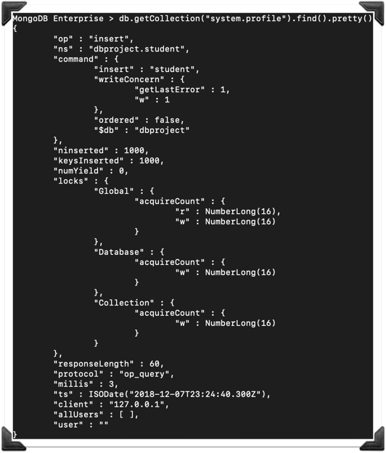

If we look at the data logs we will be able to see there is max number of inserts per log is 1000. So if we inserted 5 files each with 100,1000,10000,100000 and 1000000 respectively. So, it’s is inserting no more than 1000 documents at a time. And the total number of logs are 1113 as shown below



Oracle table Creation: -

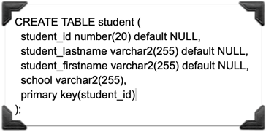

Oracle SP to insert data: -

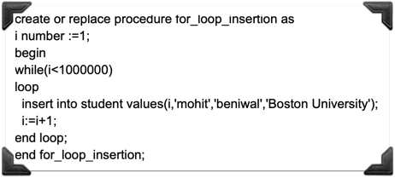

To insert data into oracle student table I have followed 2 approach:-

1. Directly writing query in Sql Developer Query editer.

Query: -insert into student values(1,'mohit','beniwal','Boston University');

1. Insertion using Store Procedure.

Query: - execute for_loop_insertion;

I have inserted 100,1000,10000,100000 and 1000000 rows respectively, using both approaches. Below is the tabular and graphical representation of the time taken by queries in MongoDB and Oracle(with Sp and without Sp).

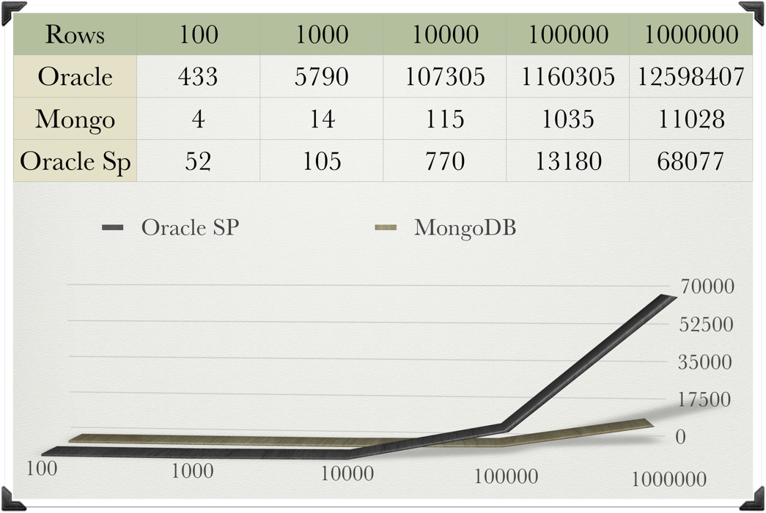

If I take Oracle Sps data into consideration for this particular operation I found that mongodb is 6 time faster than oracle.

**Selection**: -

MongoDB Query:-

Mongo 1:-

1. db.student.find().limit(100).explain(“executionStats”)
2. db.student.find().limit(1000).explain(“executionStats”)
3. db.student.find().limit(10000).explain(“executionStats”)
4. db.student.find().limit(100000).explain(“executionStats”)
5. db.student.find().limit(1000000).explain(“executionStats”)

Mongo 2:-

1. db.student.find({“student_id”:{$lt:100}}).explain("executionStats")
2. db.student.find({“student_id”:{$lt:1000}}).explain("executionStats")
3. db.student.find({“student_id”:{$lt:10000}}).explain("executionStats")
4. db.student.find({“student_id”:{$lt:100000}}).explain("executionStats")
5. db.student.find({“student_id”:{$lt:1000000}}).explain("executionStats")

Oracle Query:-

1. select * from student fetch first 100 rows only;
2. select * from student fetch first 1000 rows only;
3. select * from student fetch first 10000 rows only;
4. select * from student fetch first 100000 rows only;
5. select * from student fetch first 1000000 rows only;

After running these above mentioned 15 query I am getting the execution time as shown:-

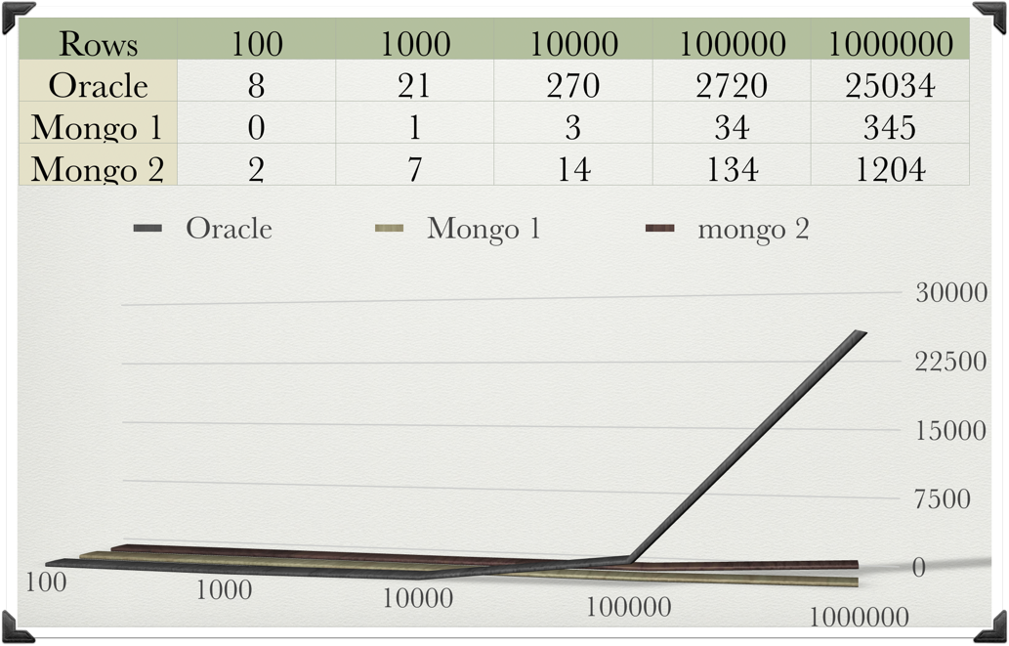

MongoDBs limit function is much faster than its conditional selects.

Taking Mongo 2 and oracle into consideration I can say that the for select queries mongoDB is approximately 20 time Faster than oracle.

**Updating: - 1st Approach:-**

Oracle Update using PK: - Execution time:- 98 ms :-

Query:- update student set student_lastname='beniwal' where student_id=999999

Oracle Update on non-indexed column: - Execution Time:- 3370 ms update student set student_firstname='mohit' where student_lastname='beniwal'

MongoDB Update on non-indexed field: - Execution Time:- 441 ms db.student.update({“student_id”:999999},{$set :{“student_lastname":"beniwal"}})

MongoDB Indexing :-

db.student.ensureIndex({“student_id”:1})

After Indexing “student_id” Execution Time for that same query in mongodb is 0 ms.

MongoDB Update on _id :-Execution Time :- 0 ms db.student.update({“_id” : ObjectId(“5bf6f7ae1255ee968a17eaf8")},{$set :{“student_firstname":"mohit"}})

After running the above query getting the results as shown in the bar graph.

* OI represents: - oracle query on indexed column.
* O represents: - Oracle query on non-indexed column.
* M represents: - MongoDb query on non-indexed column.
* MI represents: - MongoDb query on indexed column.

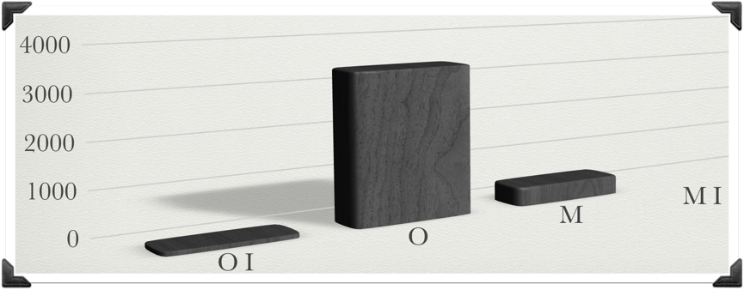

After looking at the results it is clear that the monoDB performance is better than oracle.

**Oracle Update:- 2nd approach** Here I have followed the same approach of running the queries for 100 to 1000000 records.

Oracle Query:-

1. Update student set student_lastname='beniwal',student_firstname='mohit' where student_id<100
2. Update student set student_lastname='beniwal',student_firstname='mohit' where student_id<1000
3. Update student set student_lastname='beniwal',student_firstname='mohit' where student_id<10000
4. Update student set student_lastname='beniwal',student_firstname='mohit' where student_id<100000
5. Update student set student_lastname='beniwal',student_firstname='mohit' where student_id<1000000

MongoDb Update:-

1. db.student.explain(“executionStats”).update({"student_id":{$lte:100}},{$set:{"student_lastname":"beniwal","student_firstname":"mohit"}},{multi:true})
2. db.student.explain(“executionStats”).update({"student_id":{$lte:1000}},{$set:{"student_lastname":"beniwal","student_firstname":"mohit"}},{multi:true})
3. db.student.explain(“executionStats”).update({"student_id":{$lte:10000}},{$set:{"student_lastname":"beniwal","student_firstname":"mohit"}},{multi:true})
4. db.student.explain(“executionStats”).update({"student_id":{$lte:100000}},{$set:{"student_lastname":"beniwal","student_firstname":"mohit"}},{multi:true})
5. db.student.explain(“executionStats”).update({"student_id":{$lte:1000000}},{$set:{"student_lastname":"beniwal","student_firstname":"mohit"}},{multi:true})

Below is the tabular and graphical representation of the result of the above 10 queries.

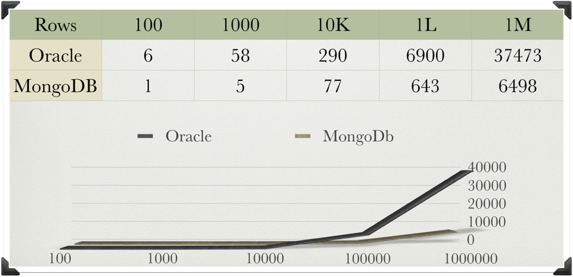

**Deletion: - 1st approach**

In this approach I am deleting on a condition which is true only for one row, so it will look into the whole table but deletetion will be performed only on one record for both Oracle and MongoDb

Oracle Delete:- Execution Time:- 178 ms Delete from student where student_lastname=‘beniwal'

MongoDB remove :- Execution Time :- 430 ms

db.student.remove({“student_lastname":"beniwal"})

db.student.explain(“executionStats").remove({"student_lastname":"beniwal"})

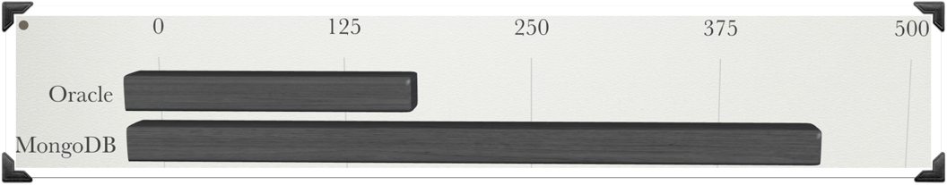 We can see from the above graph MongoDb is taking more time in this particular case.

**2nd Approach:-**

Here I have followed the same approach of running the queries for 100 to 1000000 records.

Oracle Delete:-

1. delete from student where student_id<100
2. delete from student where student_id<1000
3. delete from student where student_id<10000
4. delete from student where student_id<100000
5. delete from student where student_id<1000000

MongoDb Delete:-

1. db.student.explain(“executionStats").remove({"student_id":{$lte:100}})
2. db.student.explain(“executionStats").remove({"student_id":{$lte:1000}})
3. db.student.explain(“executionStats").remove({"student_id":{$lte:10000}})
4. db.student.explain(“executionStats").remove({"student_id":{$lte:100000}})
5. db.student.explain(“executionStats").remove({"student_id":{$lte:1000000}})

Below is the tabular and graphical representation of result of the above 10 queries.

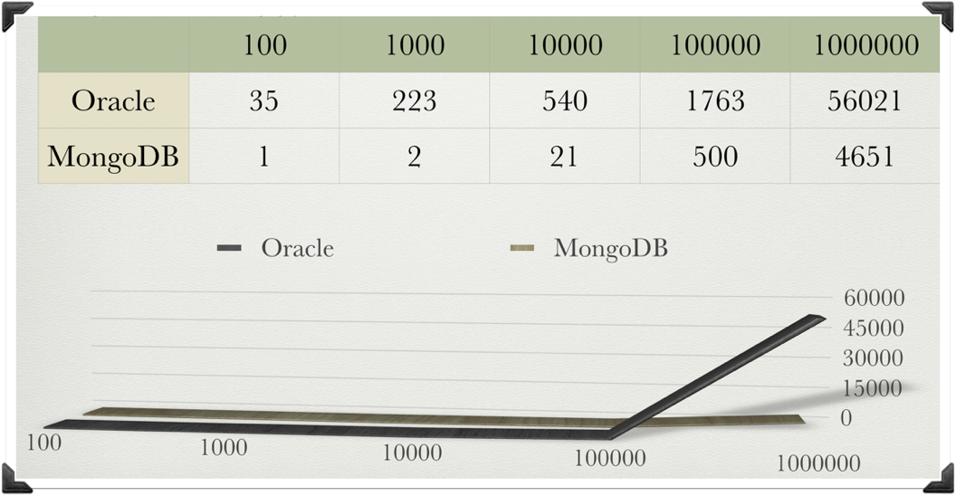

As now we are actually deleting the multiple rows while navigating in the table so Oracle is taking almost 12 times more time than MongoDB.

Conclusion

I am concluding the performance results based on the above discussed queries in the report for Insertion, Selection, Updation and deletion as follow.

* MongoDB Import is approximately 6 times faster.
* MongoDB Select is approximately 20 time faster.
* MongoDB Update is approximately 5.7 time faster.
* MongoDB Remove is approximately 12 time faster.

References

* <https://docs.mongodb.com>
* <https://www.mongodb.com/scale/nosql-explained>
* <https://www.mongodb.com/scale/types-of-nosql-database-management-systems>